Hybrid Course Checklist
Required course elements:
- Embodied Faith/Mission (Faith integration, Christian practices, vocation/calling etc…)
Each week should contain:
- Three graded submissions during the week with different due dates (discussions, assignments, quizzes, one can be attendance in a Zoom or F2F session, anything that is graded)
- Of the three, a minimum of two must include student-to-student interaction (Zoom or F2F session counts as one, a discussion, group assignment, collaborations, shared digital boards, social media updates, etc.)
- Online Synchronous or F2F sessions need agendas communicating how content is tied to the online portion of the course.
- Clear explicit instructions in online graded content this includes: homework, discussion boards, assignments, group work etc
  - These should all have grading rubrics or checklists.
  - ID team can help develop rubrics or checklists and we currently have general rubrics available for use
- Weekly Overviews
  - Quick overview (text or video) letting students know what the week includes. A bit like standing in front of the room and saying “this week we will…”
  - Weekly learning outcomes aligned to course learning outcomes
  - Required Reading and resources
  - Recommended Resources (optional)
  - Estimated time it will take to complete work for the week
    - Example: Participating in this week's activities and completing the assignments will take approximately 18 hours.
Syllabus must contain the following:
- Course Description
- Course Learning Outcomes
- Instructor Contact Information
- Required Textbooks/ supplies
- Grading policy including grading scale and either points or weighted grades
- Expectations for late or incomplete work
  - PLNU policies as provided in syllabus template
All courses must be ADA compliant
- Self-describing links
- Use bullet and number list features within Canvas Rich Text Editor
- Table must have labels
- All non-decorative images must have alternative text
- If an image is providing content (e.g. tables), a caption or transcript is required
- Video and audio must have transcription or closed caption
- Do not use underlining in the online environment to bring attention to text as it indicates a live link.
- Do not use color to identify content information.
- Scanned documents are not ADA or often copyright compliant

Online Course Checklist
Required course elements:
- How to get started on the home or landing page
- Ask Your Instructor forum
  - Will be included in the template assigned to your department
- Course Orientation providing students with navigation instructions and important course information.
- Meet Your Instructor page
  - Will be included in the template assigned to your department
- Introduction or Ice Breaker Discussion or Interaction
- Embodied Faith/Mission (Faith integration, Christian practices, vocation/calling etc…)

Each week must contain:
- Three graded submissions during the week with different due dates (discussions, assignments, quizzes, anything that is graded)
- Of the three, a minimum of two must include student-to-student interaction (discussions, group assignments, collaborations, shared digital boards, social media updates, etc.)
- Clear explicit instructions in online graded content this includes: homework, discussion boards, assignments, group work etc
  - These should all have grading rubrics or checklists.
  - ID team can help develop rubrics or checklists and we currently have general rubrics available for use
- Weekly Overviews
  - Quick overview (text or video) letting students know what the week includes. A bit like standing in front of the room and saying “this week we will…”
  - Weekly learning outcomes aligned to course learning outcomes
  - Required Reading and resources
  - Recommended Resources (optional)
  - Estimated time it will take to complete work for the week
    - Example: Participating in this week's activities and completing the assignments will take approximately 18 hours.
Syllabus must contain the following:
- Course Description
- Course Learning Outcomes
- Instructor Contact Information
- Required Textbooks/ supplies
- Grading policy including grading scale and either points or weighted grades
- Expectations for late or incomplete work
  - PLNU policies as provided in syllabus template
All courses must be ADA compliant
- Self-describing links
- Use bullet and number list features within Canvas Rich Text Editor
- Table must have labels
- All non-decorative images must have alternative text
- If an image is providing content (e.g. tables), a caption or transcript is required
- Video and audio must have transcription or closed caption
- Do not use underlining in the online environment to bring attention to text as it indicates a live link.
- Do not use color to identify content information.
- Scanned documents are not ADA or often copyright compliant

Examples:
Weekly Overview page…
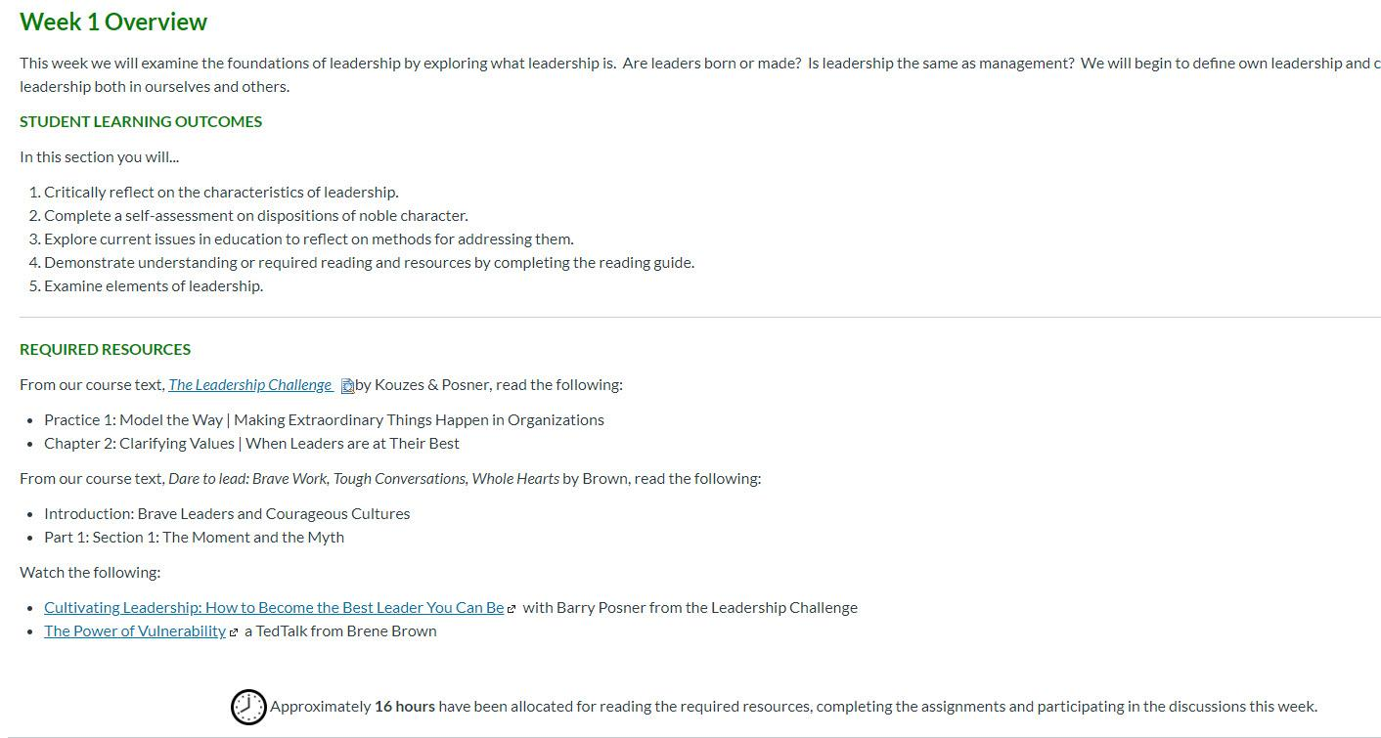

Meet Your Instructor…
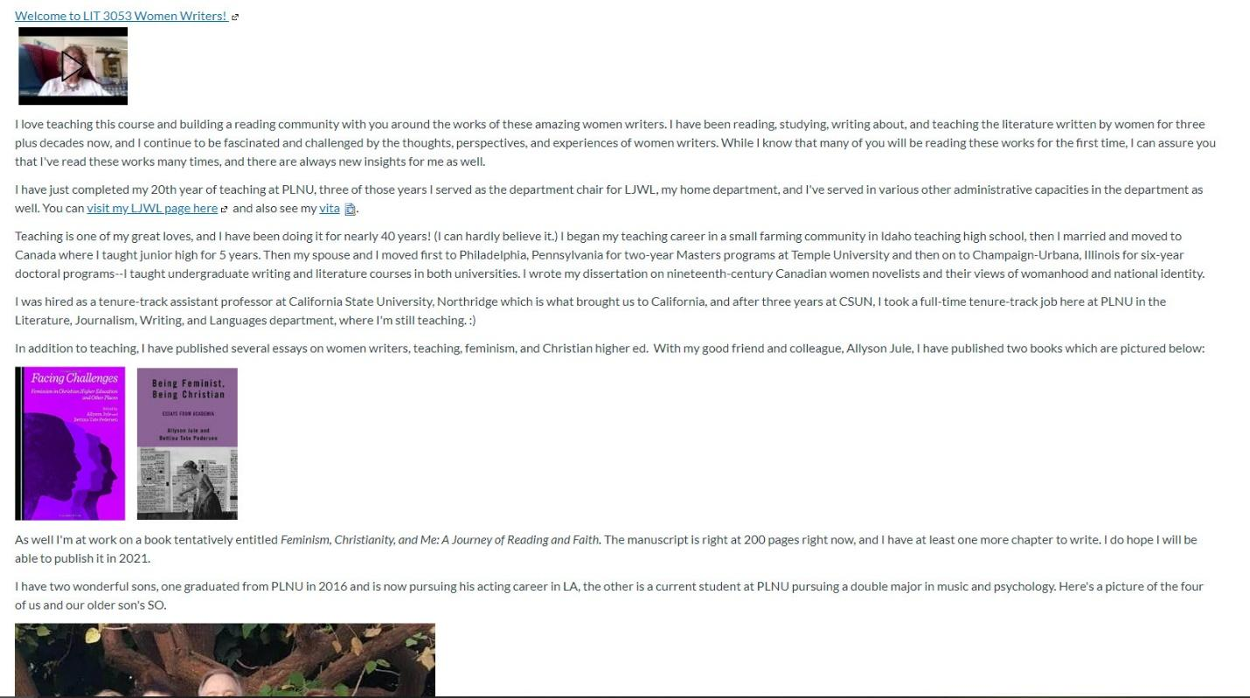

Course Orientation…
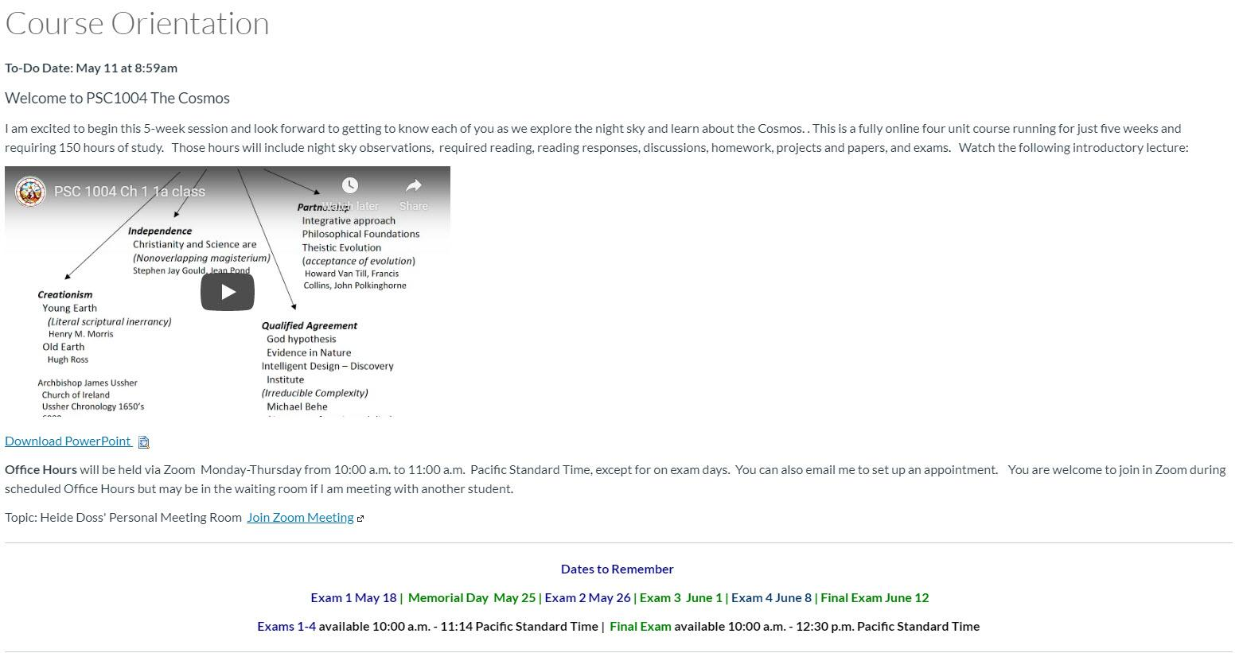
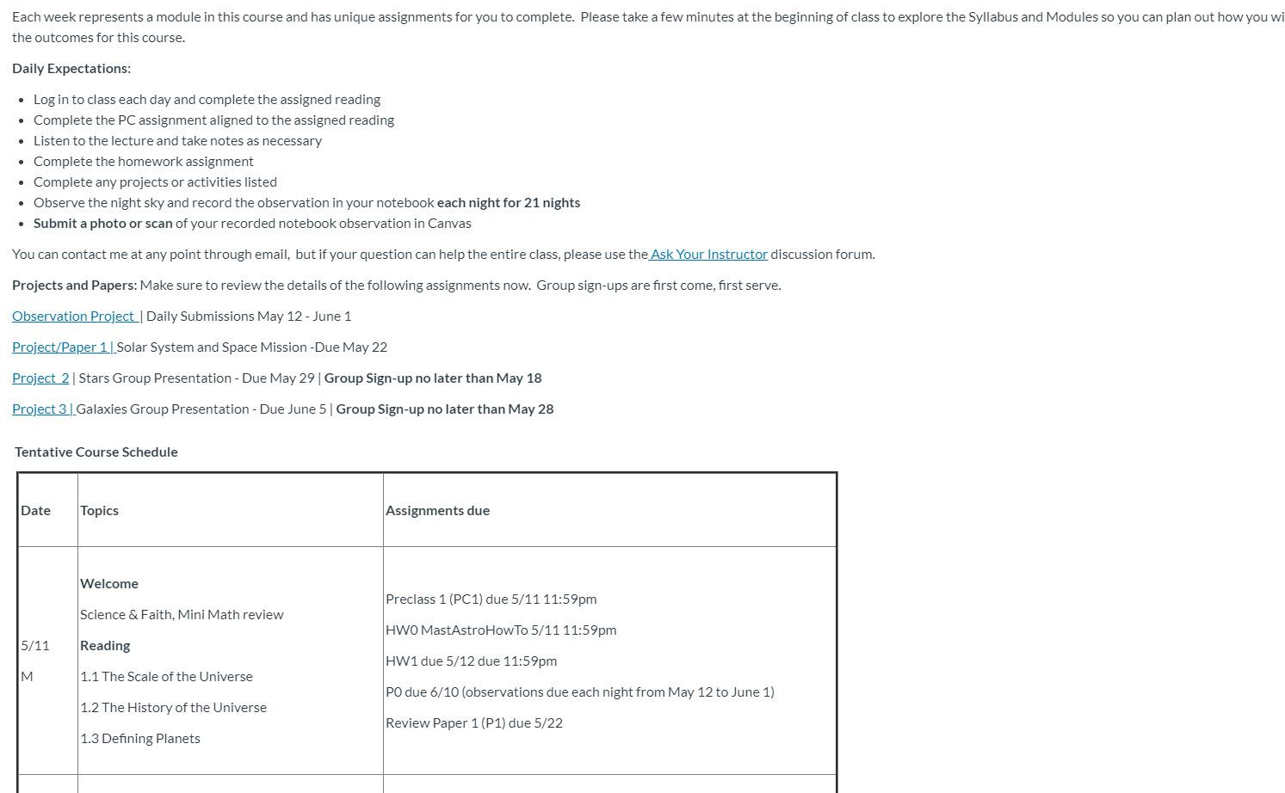

Introduction discussion…
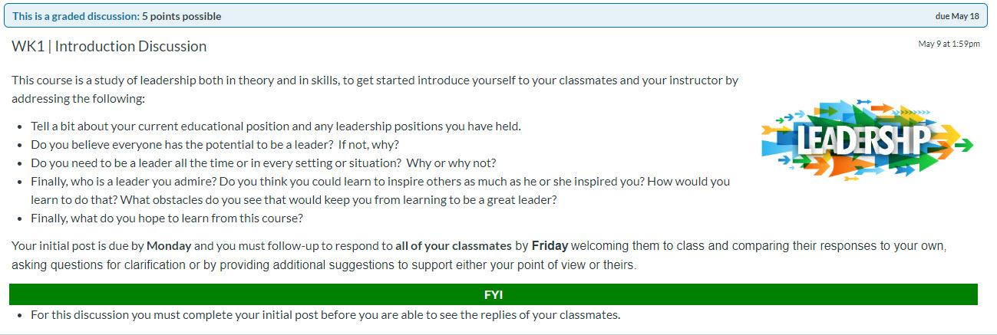

Faith integration…
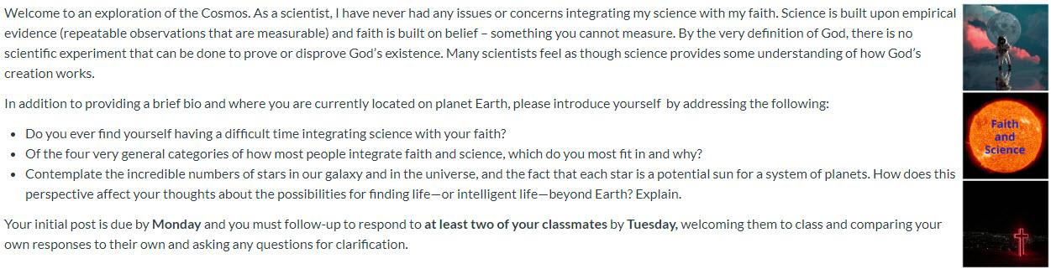

Syllabus Weighted Grades ….
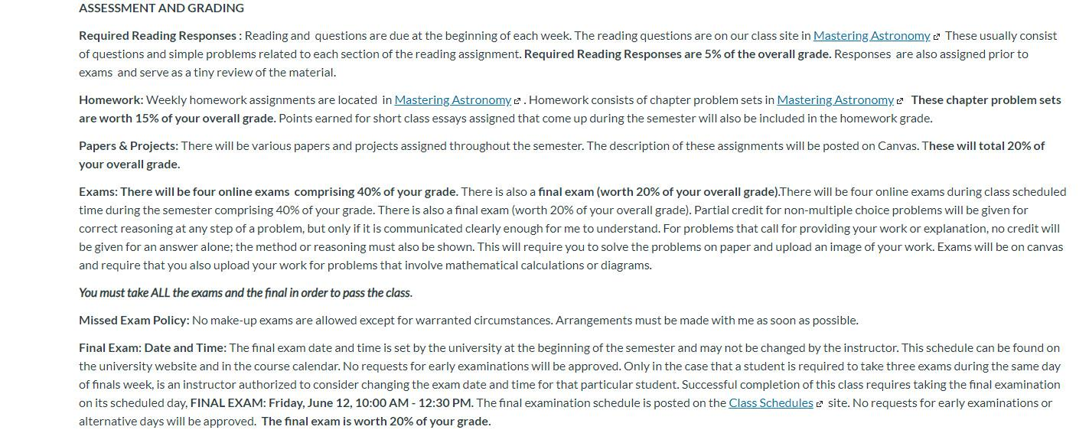
Syllabus Points….

ASSESSMENT AND GRADING

Students are expected to attend all class sessions, participate in class activities, complete exams as scheduled, and turn in assignments on time, or risk the loss of points. Approximate points available are as follows:

Peregrine Course Leveling Module | 50
Weekly post and responses to fellow student | 280
CESIM Global Challenge Simulation | 320
Interview Paper | 100
Final Case | 50
Midterm/Final Exam | 200
Survey and Evaluation
Total Points Available | 1,000

Grading: The following represents the general grading policy for this class:

93.0-100.0% | A | 73.0-76.9% | C
90.0-92.9% | A- | 70.0-72.9% | C-
87.0-89.9% | B+ | 67.0-69.9% | D+
83.0-86.9% | B | 63.0-66.9% | D
80.0-82.9% | B- | 60.0-62.9% | D-
77.0-79.9% | C+ | 0-59.9% | F

